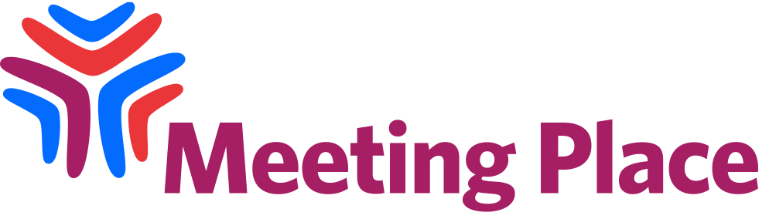

Charter of Rights & Responsibilities

Meeting Place 2021 strives to create a space that is universally accessible for all.

Arts Access Australia strives to meet all access requests requested by event attendees. Online program sessions will include Auslan-interpreting, live captioning and audio description. Recordings and transcripts will be available to all Meeting Place 2021 ticket-holders where possible. Please note that the Code of Conduct public consultation will not be recorded.

Arts Access Australia promotes a human rights approach to access and inclusion and is committed to creating a space that respects rights and responsibilities.

We believe that there is a shared responsibility for creating access and inclusion, and this starts with acknowledging our personal rights and responsibilities and respecting the rights and responsibility of others.

The following Charter of Rights and Responsibilities has been created to guide participation in our online event.

Access Support – I acknowledge that this event is for Deaf and Disabled people, and I will assist to create a supportive space by respecting:

- Physical Access – creating space for wheelchairs and leaving chairs for people who need to sit down.
- Sensory Access – keeping noise to a minimum, not using flash photography, and avoiding the use of strong perfumes and fragrances.
- General Access & Support – being aware of the general wellbeing of others, assisting people to find help when they need it, and being kind and courteous when using video chat functions and/or asking questions.

Safety - I will help create a safe, constructive and harassment-free space for everybody.

Freedom of Opinion - I will respect the views and opinions of others and allow them the time and space in which to share them.

Mindfulness - I will be considerate in what I do and say, the language I use and mindful of the effect that I might have on other people.

Privacy - I will not take photos, videos or screenshots of people or chat conversations without permission.

Action & Response - I will report any offensive, unacceptable or unsafe behaviour to the Meeting Place chat moderators. I acknowledge that I may be asked to leave if my behaviour is deemed offensive, unacceptable or unsafe.

